Guadalupe County Master Gardeners

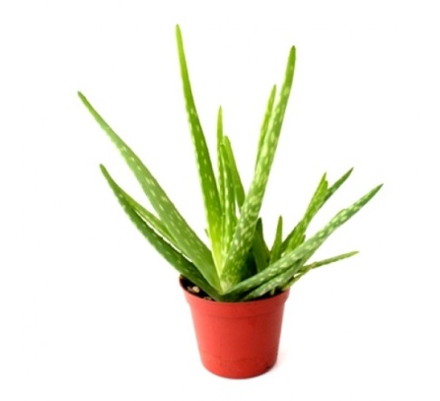
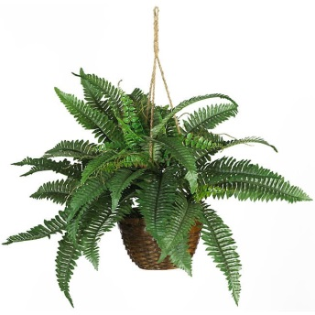

House Plants that Clean Contaminants from Indoor Air
Presented by Marvin Borth

Monday April 9, 2018
12–1pm

Free. Everyone is welcome.

Where: Guadalupe County Office Building (Annex), 1101 Elbel Road, Schertz Texas 78154

Educational programs of the Texas A&M AgriLife Extension and Master Gardeners provide equal opportunities in its programs and employment to all persons, regardless of race, color, sex, religion, national origin, age, genetic information, veteran status, sexual orientation, or gender identity. The Texas A&M University System, U.S. Department of Agriculture, and the County Commissioners Courts of Texas Cooperating.

